IS362 - Cohen
Homework Assignment #1 – Python Basics
Connections to Course Objectives & Learning Goals:
Course Objectives:
- To hone data mining execution using the Python programming language
Learning Goals:
- Analytical and Technological skills
- Oral and written communication skills

The objective of this assignment is to practice coding fundamentals in Python. If you need a refresher, coding basics can be found below. Refresh your skills through Numpy & Pandas basics:
- https://python.swaroopch.com/data_structures.html
- https://www.learnpython.org/en/Hello%2C_World%21
The homework must be screenshots of your code from Jupyter Notebook pasted into this MS-WORD and include the Jupyter notebook as well as part of your submission. As an example, just sending the Word document without the Jupyter notebook will receive 50% credit.

Grading Rubric
25 points is the best possible grade. Each question represents 2.5 points, out of 25 possible points.
- If there is no Jupyter notebook, or if it is not an .ipynb file there is a -50% point deduction on the entire assignment.
- If the homework is not submitted as an attachment to the email e.g. sent as a link via email or sent as a PDF, there is a -50% point deduction on the entire assignment.

- Let’s do an exercise in combining variables, given an input.
  - Given input
one = 1
two = 2
three = 3
four = 4
can = can
do = do
python = python
more = more
  - Expected output:
1 2 3 4 can do python more
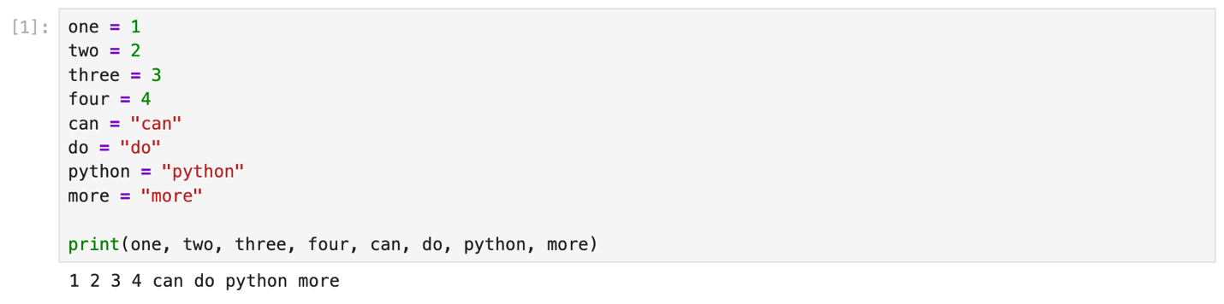
- Based upon these numbers, please take a picture using the “Snip” function to show the code and output provide the given Input:
  - Given Input
number1 = 15
number2 = 30
  - Expected output
The result is 450

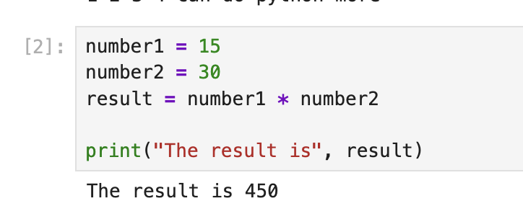
- Write a function to return True if the first and last number of a given list is same. If numbers are different then return False.
  - Given input:
numbers_x = [10, 20, 30, 40, 10]
numbers_y = [75, 65, 35, 75, 30]
  - Expected output:
Given list: [10, 20, 30, 40, 10]
result is True
numbers_y = [75, 65, 35, 75, 30]
result is False
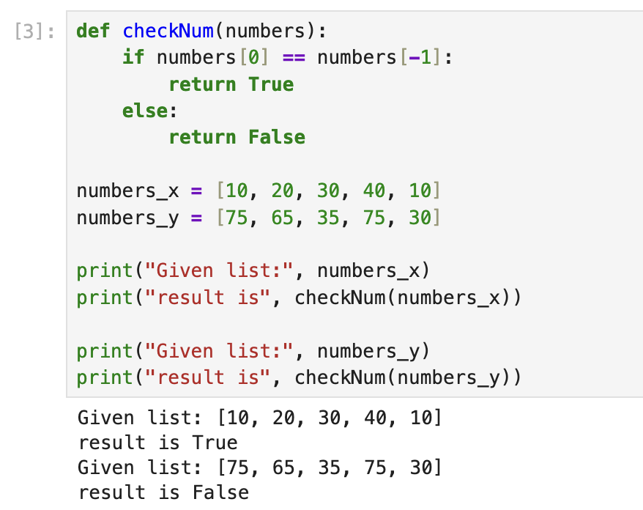

- Iterate the given list (from #3) of numbers and print only those numbers which are divisible by 5
  - Expected Output:
Given list is [10, 20, 33, 46, 55]
Divisible by 5
10
20
55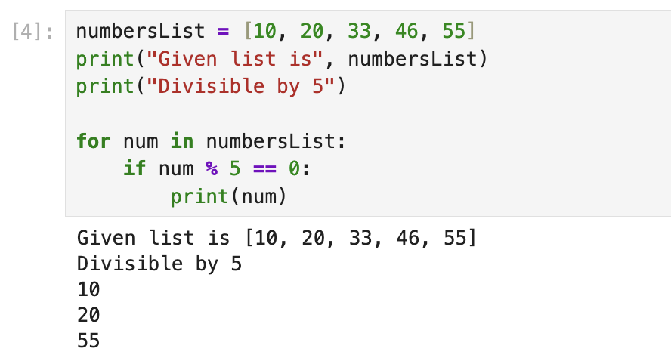
- Write a program to find how many times substring “Anjali” appears in the given string.
  - Given input:
str_x = "Anjali is good developer. Anjali is a writer"
  - Expected output:
Anjali appeared 2 times
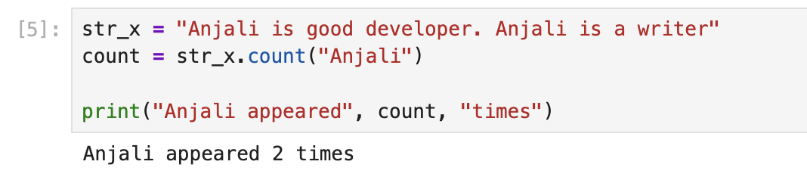
- Print the following pattern:
  - Expected output:
1
2 2
3 3 3
4 4 4 4
5 5 5 5 5
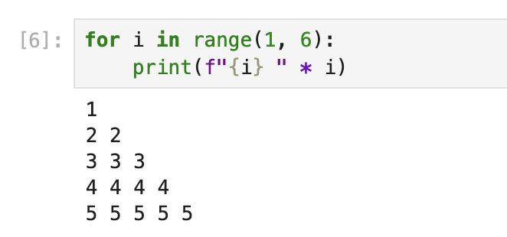
- Print a multiplication table from 1 to 100:
  - Expected output:
1 2 3 4 5 6 7 8 9 10
2 4 6 8 10 12 14 16 18 20
3 6 9 12 15 18 21 24 27 30
4 8 12 16 20 24 28 32 36 40
5 10 15 20 25 30 35 40 45 50
6 12 18 24 30 36 42 48 54 60
7 14 21 28 35 42 49 56 63 70
8 16 24 32 40 48 56 64 72 80
9 18 27 36 45 54 63 72 81 90
10 20 30 40 50 60 70 80 90 100
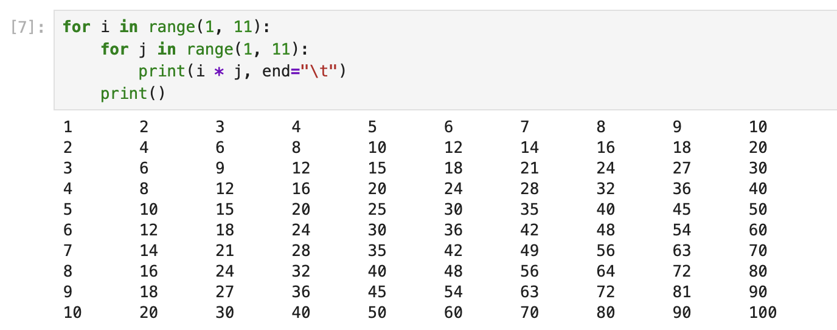
- Let’s now use Numpy to convert a list to an array. First, convert the list of weights from a list to a Numpy array. Then, convert all of the weights from kilograms to pounds. Use the formula Celsius (°C) = Kelvin - 273.15 to convert Kelvin to Celsius. Lastly, print the resulting array of temperatures in Celsius.
  - Given input:
Temp_K = [390.65, 107.52, 225.25, 275.98, 318.18, 88.45]
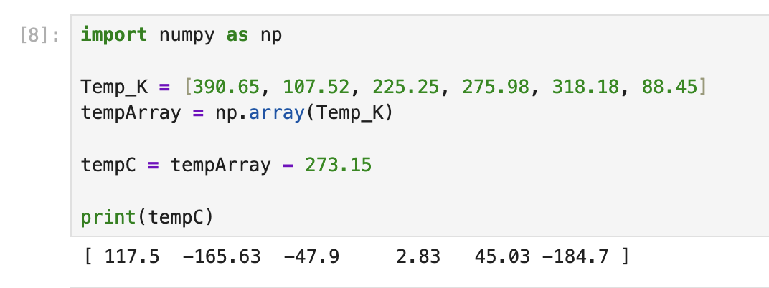
- Let’s build a Dataframe in Pandas.
  - Use a dictionary to create four fields:
    - Student (use Tommy, Fred, Gail, [your first name], Randy, and Ariel)
    - Hair Color (use Brown, Grey, Blonde, [your hair color] , Black and Brown)
    - Eye Color (use Hazel, Green, Blue, [your eye color], Hazel and Blue)
    - Weight in kilograms (60, 80, 76, 60, 88, 85)
  - Index the dataframe
  - Print out the entire dataframe
  - # Print out hair color column as Pandas Series
  - # Print out eye color column as Pandas DataFrame
  - # Print out DataFrame with student and weight columns
  - # Print out the second through fourth observations
- We will count #9 as double points.

